SENIOR FIVE TERM 1

TOPIC 1/3: The Structure of the Earth
Competency: The learner demonstrates appreciation of the structure of the Earth and its influence on geomorphic processes and formation of some natural resources by examining the properties of each of its layers to better understand the geologic foundation of human development.

The External Structure of the Earth
The Earth's "external structure" can refer to two concepts: the planet's major interacting physical systems (spheres) or its rigid outer shell (the lithosphere).

Earth's External Spheres
The Earth system is typically divided into four major, interacting spheres that form its external environment:
Atmosphere
The layer of gases surrounding the planet, primarily composed of nitrogen (78%) and oxygen (21%). It protects the surface from solar radiation, absorbs and emits heat, and is where weather occurs. It is further divided into layers: the troposphere, stratosphere (which contains the ozone layer), mesosphere, and thermosphere.
Hydrosphere:
Encompasses all of the Earth's water in solid, liquid, and gaseous forms, including oceans, lakes, rivers, groundwater, and ice. The global ocean covers about 71% of the Earth's surface.
Lithosphere:
The solid, rocky outer part of the Earth, including the crust and the brittle upper portion of the mantle. It is broken into large segments called tectonic plates, which move slowly and whose interactions cause earthquakes, volcanoes, and mountain building.
Biosphere:
The sphere that contains all the planet's living things, from microorganisms to plants and animals, interacting within ecological communities called biomes.

Earth's internal structure
Earth's internal structure consists of three main chemical layers—the thin crust, the thick mantle, and the dense core, which is split into a liquid outer core and solid inner core—but also has mechanical layers like the rigid lithosphere (crust + upper mantle) and the flowing asthenosphere, with the liquid outer core's movement generating Earth's magnetic field.

(i) Crust
- The outermost solid layer where we live.
- Thickness: 5–70 km.
- Two types:
  - Continental crust: thicker, less dense, mainly granite.
  - Oceanic crust: thinner, denser, mainly basalt.
- Separated from the mantle by the Mohorovičić discontinuity (Moho).

(ii) Mantle
- Extends from the Moho down to ~2,900 km.
- Composed mainly of silicate minerals rich in magnesium and iron.
- Divided into:
  - Upper mantle: includes the asthenosphere, partly molten and responsible for plate tectonics.
  - Lower mantle: more rigid due to higher pressure.
- Heat transfer occurs through mantle convection, driving earthquakes and volcanism.

(iii) Outer Core
- Depth: ~2,900–5,150 km.
- Composed of liquid iron and nickel.
- Movement of molten metal generates Earth’s magnetic field.
- Responsible for geomagnetic phenomena like auroras.

4. Inner Core
- Depth: ~5,150–6,371 km.
- Solid sphere of iron and nickel due to immense pressure.
- Extremely hot (up to 5,700 °C), comparable to the Sun’s surface. • Plays a role in stabilizing Earth’s magnetic field.
Comparison Table
Layer | Depth Range | State | Composition | Key Role
Crust | 0–70 km | Solid | Granite, basalt | Land, ocean floor
Mantle | 70–2,900 km | Solid (plastic in parts) | Silicate minerals | Plate tectonics, volcanism
Outer  Core | 2,900–5,150 km | Liquid | Iron, nickel | Generates magnetic  field
Inner Core | 5,150–6,371 km | Solid | Iron, nickel | Stabilizes magnetic field

Methods of Studying Earth’s Interior

Direct Methods
- Mining and drilling: Humans have drilled up to ~12 km deep (Kola Superdeep Borehole), but this is tiny compared to Earth’s 6,371 km radius.
- Volcanic eruptions: Magma and gases expelled from volcanoes provide samples of material from beneath the crust.
- Exposed rocks: Erosion and tectonic uplift reveal deeper rocks at the surface, giving clues about subsurface composition.

Indirect Methods
- Seismology: The most important technique. Seismic waves from earthquakes travel differently through solid and liquid layers, allowing scientists to map the crust, mantle, and core.
- Gravity studies: Variations in Earth’s gravitational field reveal density differences inside the planet.
- Magnetic field analysis: Earth’s magnetic field originates in the liquid outer core; studying its behavior helps understand core dynamics.
- Laboratory experiments: High-pressure and high-temperature simulations recreate conditions of Earth’s interior to test how rocks behave.
- Meteorite studies: Since meteorites are remnants of early solar system material, they provide analogs for Earth’s internal composition.
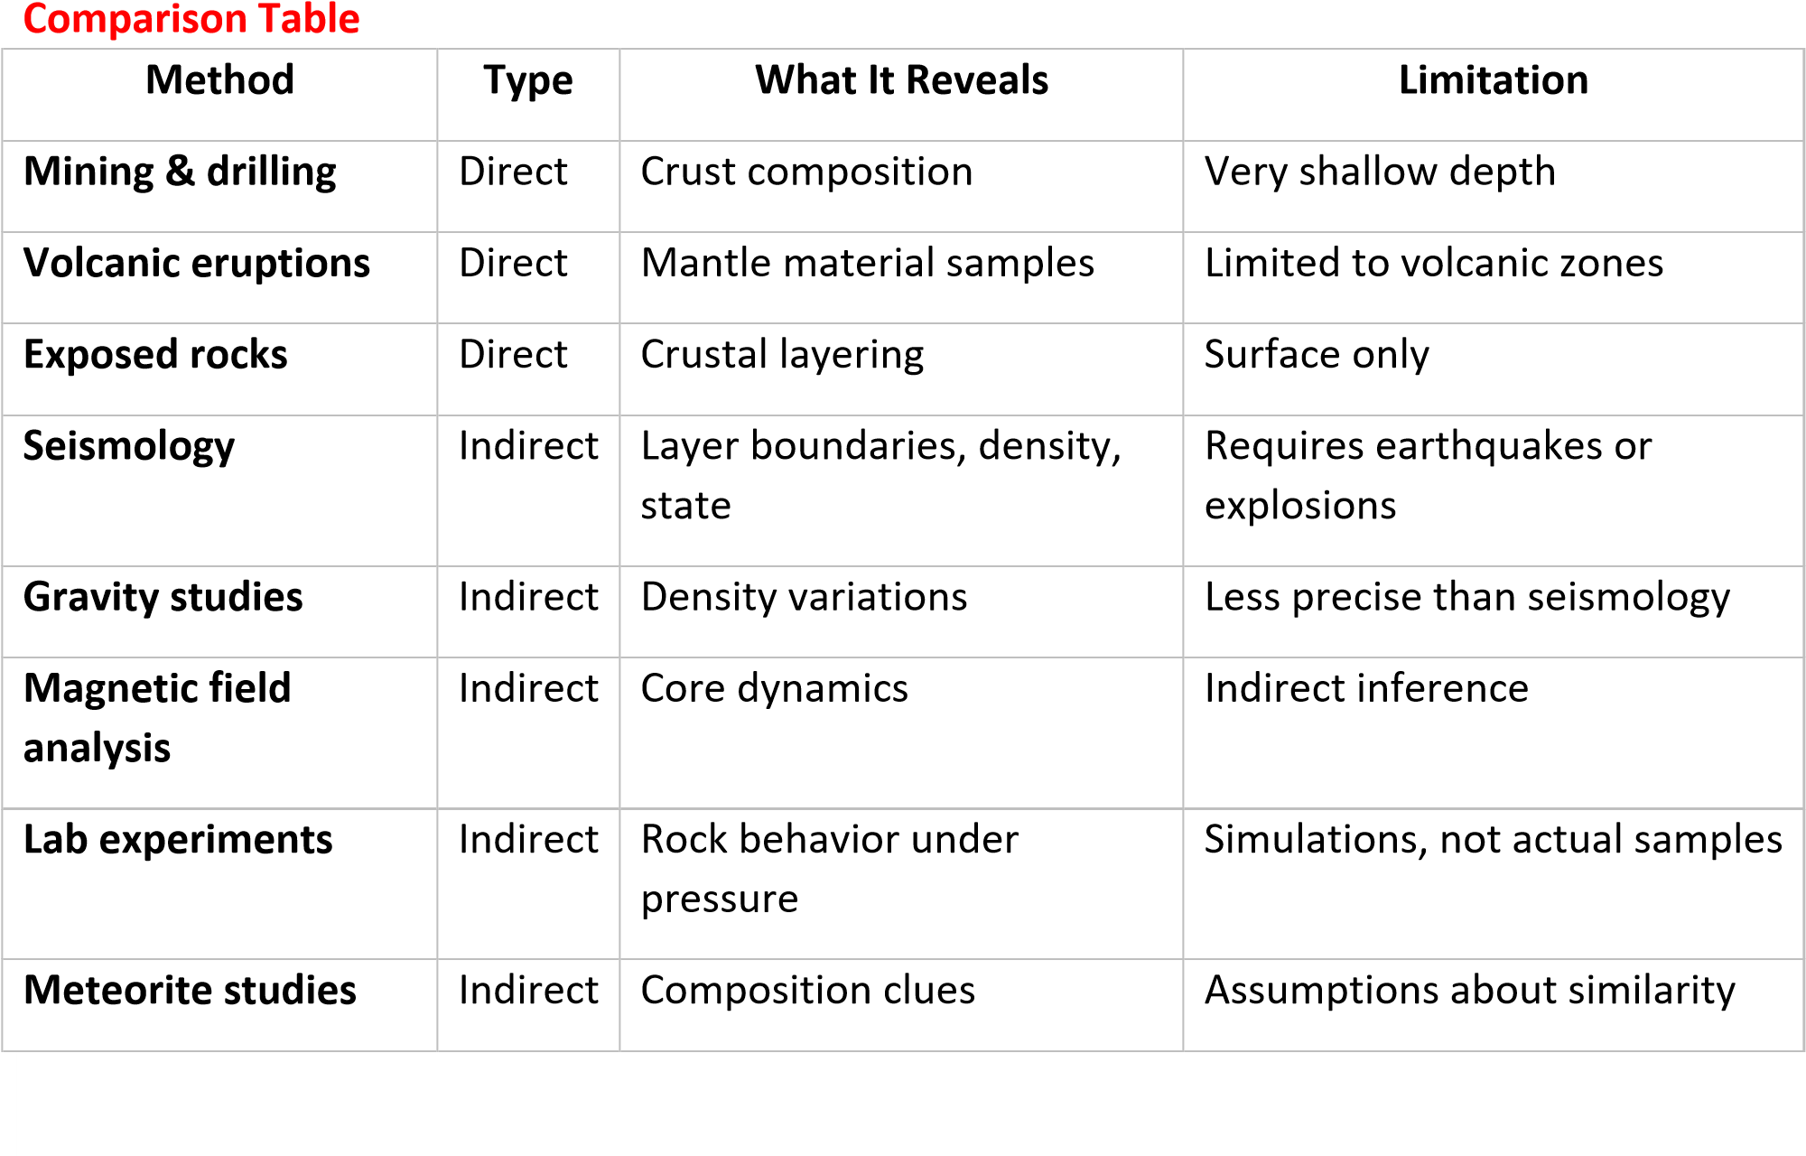

The link between the properties of the internal layers of the Earth, geomorphic processes; and their impact on humans

Internal Layers and Their Properties
- Crust: Solid, brittle outer shell.
- Mantle: Semi-solid/plastic, convecting layer.
- Outer Core: Liquid iron and nickel, generates magnetic field.
- Inner Core: Solid iron-nickel sphere, stabilizes magnetic field.

Geomorphic Processes Driven by Internal Layers
- Plate Tectonics (Crust + Upper Mantle): Movement of lithospheric plates causes earthquakes, mountain building, and volcanism.
- Volcanism (Mantle): Rising magma creates volcanoes, islands, and new crust.
- Earthquakes (Crust + Mantle): Sudden release of stress along faults shakes the surface.
- Isostatic Adjustment (Crust + Mantle): Land rises or sinks due to loading/unloading (e.g., glaciers melting).

• Magnetism (Outer Core): Earth’s magnetic field shields life from harmful solar radiation Impacts of Earth’s internal layers and geomorphic processes on humans Hazards
- Earthquakes destroy infrastructure and cause loss of life. o Volcanic eruptions damage settlements but also enrich soils. o Tsunamis (triggered by tectonics) devastate coastal communities. Resources
- Minerals and fossil fuels originate in crustal and mantle processes. o Geothermal energy harnesses mantle heat. o Fertile volcanic soils support agriculture. Protection o Magnetic field (outer core) protects humans and technology from solar radiation. Linking Table
Internal
Layer

Property

Geomorphic Process

Human Impact

Crust

Solid, brittle

Plate tectonics,
earthquakes

Hazards, mineral resources

Mantle

Semi
-
solid,
convecting

Volcanism, mountain
building

Fertile soils, geothermal
energy

Outer Core

Liquid iron
-
nickel

Magnetic field generation

Radiation protection,
navigation

Inner Core

Solid iron
-
nickel

Stabilizes field

Long
-
term
planetary
habitability

TOPIC 2/3: The Origin of Continents and Ocean Basins
Competency: The learner demonstrates an understanding of the role of theories in exploring geomorphic concepts by critically evaluating the continental drift theory based on scientific evidence to inform further geographical inquiry and to acquire problem-solving skills.
A continent is a large, continuous mass of land on Earth, usually separated by oceans and distinguished by geography, culture, and history. Most English-speaking countries recognize seven continents: Asia, Africa, North America, South America, Antarctica, Europe, and Australia/Oceania
An ocean basin is a large, saucer-like depression on Earth’s surface that holds the oceans. They cover about 71% of Earth’s surface, with an average depth of 16,000 feet (≈4,900 m)

Continental drift
Continental drift is the hypothesis that the Earth's continents have moved over geologic time relative to each other and are still moving even today.
The forces responsible for the drifting of continents
- Mantle convection currents: Heat from Earth’s core causes molten rock in the mantle to circulate. These convection currents drag the tectonic plates (and continents) above them, causing movement.
- Ridge push: At mid-ocean ridges, magma rises and solidifies, creating new crust. The elevated ridge exerts a force that pushes plates away from the ridge.
- Slab pull: At subduction zones, a dense oceanic plate sinks into the mantle. The sinking slab pulls the rest of the plate along, driving continental drift.
- Gravitational forces: Gravity helps in the downward movement of plates at subduction zones. It also influences the sliding of plates away from elevated ridges.
- Earth’s rotation (minor factor): Early theories suggested centrifugal force from Earth’s rotation contributed, but modern science sees this as negligible compared to mantle dynamics.
Theories of continental drift
The several theories of continental drift include

(i) F.B Tailor’s theory of continental drift
- According to Tailor 1908 (published in 1910), originally, there were two land masses Lauratia and Gondwanaland located near the north and south poles respectively.
- These moved towards the equator because the moon came closer to the earth and exerted powerful tidal and gravitational forces on them.
- Lauratia equator ward movement resulted into tensional force near the North Pole. This caused stretching, splitting and rupturing of the landmass leading to formation of Baffin Bay, Labrador Sea and Davis Strait.
- Similarly, the displacements of the Gondwanaland from the South Pole towards the equator led to splinting of the mass into Great Australian Bight and Ross Sea around Antarctic Continent.
- Arctic sea was formed between Greenland and Siberia due to equator ward movement of Lauratia.
- Atlantic and Indian oceans were supposed to have been formed because of filling of gaps between the drifting continents with water.
- Taylor assumed that the landmasses began to move in lobe form while drifting through the zones of lesser resistance. Thus, mountains and island arcs were formed in the frontal part of the moving lobes.
- The Himalayas, Caucasus and Alps are considered to have been formed during equator ward movement of the Lauratia and Gondwanaland from the north and south poles respectively while the Rockies and Andes were formed due to westward movement of the land- masses.

Criticism of F.B Tailor’s theory of continental drift
The moon-capture tidal force mechanism was incorrect and lacked sufficient evidence.
Significance of F.B Tailor’s theory of continental drift:
F.B Tailor was the first to link mountain building to continental collisions and provided an early alternative to fixed-continent theories, influencing Alfred Wegener.

(ii) Theory of sea flow spreading

The Seafloor Spreading Theory, proposed by Harry Hess in the 1960s, explains that new oceanic crust is formed at mid-ocean ridges by rising magma, which pushes older crust outwards like a conveyor belt, eventually sinking back into the mantle at deep-sea trenches. This process is driven by convection currents in the mantle and is a key mechanism for plate tectonics.

Key Ideas
- Mid-ocean ridges are underwater mountain chains where magma rises from the mantle.
- As magma cools, it solidifies into new oceanic crust.
- This crust gradually moves away from the ridge, pushing continents apart.
- At subduction zones, old oceanic crust sinks back into the mantle, balancing Earth’s surface area.

The Evidence in support of seafloor spreading
- Pillow-shaped rocks found on the ocean floor could only have formed when molten material hardened quickly after erupting underwater.
- Age of oceanic rocks: Rocks near ridges are younger, while those farther away are older.
- Magnetic striping: Rocks on either side of ridges show symmetrical patterns of magnetic polarity reversals, recording Earth’s geomagnetic history.
- Ocean floor mapping: Revealed ridges, trenches, and fracture zones consistent with spreading.
- Heat flow studies: Higher heat near ridges, lower farther away.

(iii) Alfred Wegner’s theory of continental drift
Alfred Wegener's theory of continental drift (c. 1912) proposed that all continents were once a supercontinent (Pangaea) that broke apart and moved to their current positions, supported by evidence like matching coastlines, similar fossils, and geological features across continents.
Relevancy/Evidence for Continental Drift
- Jigsaw Puzzle Fit: Continents, particularly South America and Africa, look like they would fit together.
- Fossil Correlation: Identical plant and animal fossils (e.g., Lystrosaurus, Mesosaurus Glossopteris) are found on now-distant continents, suggesting a previous land bridge or connection.
- Rock and Mountain Correlation: Similar rock types, geological structures, and ancient mountain belts (like the Appalachians and Caledonides) appear on opposite sides of the Atlantic.
- Paleoclimate Data:
  - Glacial deposits (tillites, striations) found in tropical regions (Africa, India, South America) showed evidence of past widespread glaciation, suggesting these continents were once closer to the poles.
  - Ancient coal deposits and coral reefs (tropical indicators) found in colder regions (Europe, North America) implied they were once in warmer climates.
- Similar oil beds. Oil beds in Brazil are similar to those of Angola in Africa.
- Similarity in plant and animal species in Australia and south Africa; Africa And South America
- Palaeomagnetic evidence; Palaeomagnetism refers to ancient or fossil magnetism in rocks. It’s based on the fact that igneous rocks when cooled retain some magnetic properties which at the time of their formation, can become magnetized parallel to the Earth's magnetic field. For instance studies indicated that India, Australia, South America, the magnetic properties in the magnetized rocks no longer point in the north-south direction as it should be suggesting that during the course of drifting, rocks were twisted and changed direction.
- Existence of laterites in North America and Europe proves that these continents experienced tropical climatic conditions for formation of laterites. But with time drifted to the temperate region.
- Existence of coral reefs in the Green land, Britain, North America and yet coral reefs form in hot climatic conditions.
- Salt evaporites/beds in cold parts of U.S.A, Britain, Germany and Russia is evidence for continental drift from tropics because salt evaporites occur in tropics
- Proximity of continental land masses to the North Pole than in South Pole.

Plate tectonics
- Plate tectonics is a scientific theory that explains how major landforms and water bodies are created as a result of Earth's subterranean movements.
- Plate tectonics theory suggests that that the Earth's outer shell/crust is divided into several rigid plates/sections called tectonic plates. These float and glide over the mantle leading to changes in the earth’s surface
- There are seven major plates: African, Antarctic, Eurasian, Indo-Australian, North American, Pacific and South American.

The theory of plate-tectonics
- It is the most modern theory of continental drift.
- It explains the movement and distribution of present day continents, ocean basins and land forms.
- It proposes that the earth crust is divided into individual separate parts/tectonic plates by geochemical reactions and radioactivity in the earth’s interior. These float and move/glide on the top of Earth’s interior mantle.
- The movements of the tectonic plates results in the movement of continents /land masses and water bodies and change their positions relative to each other.
- Generally all plates move northwards, others like America move westwards while Africa, Europe, Asia, Australia move north eastwards.
- There are 3 types of plate movements/boundaries caused by convection currents which influence the distribution of continents i.e.
  - Divergent movements occurs when tectonic plates move away from one another leading to faulting, rifting and warping of crustal land masses.
On the sea floor, divergent movements produce Under-water Mountains known as the mid-ocean ridge for example the mid-Atlantic ridge and islands
  - Convergent movements occur when tectonic plates move towards one another and getting closer; when collision occurred fold mountains were formed e.g. the Himalayas due to the collision of India and Asia.
  - Continents may move towards Oceanic plates causing subduction of denser simatic rocks. Collision of plates and subduction leads to formation of trenches, volcanic and fold mountains e.g. Nazca , Java and Tonga trenches etc.
- Oceanic crust may move towards each other causing narrowing of Ocean Basins and continents move nearer leading to formation of trenches and volcanic arcs e.g. Pacific and Eurasia plates moved towards each other Marina trench and Japan volcanic arc were formed.
- Plate tectonism is responsible for land forms due to vulcanicity, faulting and warping.

Definitions

Tectonic plates
Tectonic plates are blocks of continental and ocean crust.
The earth’s surface is divided into blocks of continental and oceanic crust.

Characteristics of tectonic plates
- Plates are relatively light and therefore float on the denser rocks of the mantle and asthenosphere.
- Plates are mobile and move extremely slow on rocks of the upper mantle and driven by convective currents generated by radioactivity and geochemical reactions in the core and the mantle.
- A given plate is so rigid that if one part moves, the rest move.

Continental crust (SIAL)
Continental Crust Continental crust is made up of very old light rocks (average density 2.6) of different granites. SISAL stands for silicate and aluminum, the most abundant minerals in continental crust.

Oceanic Crust (SIMA)
Oceanic crust is made up of heavy basalt rocks (average density 3) and thickness between 5-10 kilometers (3-6 miles). SIMA stands for silicate and magnesium, the most abundant minerals in oceanic crust.

Types of plate tectonic boundaries
- A divergent boundary (constructive plate boundary/margin) occurs when two tectonic plates move away from each other widening the gap between the plates. Along these boundaries, earthquakes are common and magma (molten rock) rises from the Earth’s mantle to the surface, solidifying to create new oceanic crust. Examples include divergent tectonic boundaries include The Mid-Atlantic Ridge.
- A convergent boundary occurs when two plates come together narrowing the gap between the plates. The impact of the colliding plates can cause the edges of one or both plates to buckle up into a mountain ranges or one of the plates may bend down into a deep seafloor trench. A chain of volcanoes often forms parallel to convergent plate boundaries and powerful earthquakes are common along these boundaries. The Pacific Ring of Fire is an example of a convergent plate boundary.
At convergent plate boundaries, oceanic crust is often forced down into the mantle where it begins to melt. Magma rises into and through the other plate, solidifying into granite, the rock that makes up the continents. Thus, at convergent boundaries, continental crust is created and oceanic crust is destroyed.
- A transform plate boundary (transform plate margin) occurs when two plates sliding parallel past each other. One of the most famous transform plate boundaries occurs at the San Andreas Fault zone, which extends underwater.
Natural or human-made structures that cross a transform boundary are offset — split into pieces and carried in opposite directions. Rocks that line the boundary are pulverized as the plates grind along, creating a linear fault valley or undersea canyon. Earthquakes are common along these faults. In contrast to convergent and divergent boundaries, crust is cracked and broken at transform margins, but is not created or destroyed.

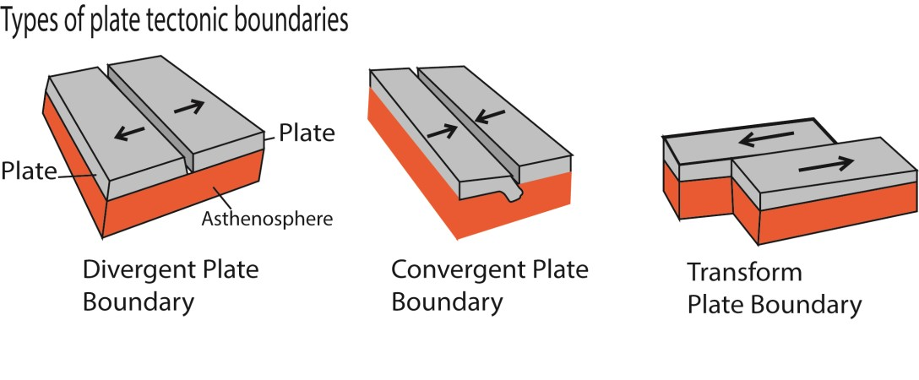
Lateral and vertical Earth movement

Lateral earth movements
- They are diastrophic or deforming (i.e. folding, faulting, warping, fracturing) movements that operate horizontally within the earth crust.
- They are caused by internal forces i.e. tensional forces (divergent forces) and compressional forces (convergent forces}, with resulting strains and stresses in the rocks.
- They lead to folding and faulting of the coast.
While

Vertical earth movements
- They are diastrophic or deforming (i.e. folding, faulting, warping, fracturing) movements that operate vertically exerting a pushing force onto the crust either upward or downward along a radius from the centre of the earth to the surface.
- They usually occur on a large scale hence called epeirogenic (slow large scale uplift) and may involve vertical uplift or subsidence.
- On local scale, vertical earth movements lead to isostatic readjustment especially around the coast leading the relative changes in the sea level.

Earthquake
An earthquake is the shaking of the surface of the Earth resulting from a sudden release of energy in the Earth's lithosphere that creates seismic waves/vibration/tremors.

Most earthquakes occur within the crust of the earth and not at the surface. The point from which the shock waves originate is known as the focus and the point directly above on the surface is known as the epicenter. The shock waves pass very rapidly through the rocks to the surface where the shaking can cause destruction of life and property. The Richter magnitude of an earthquake is determined from the logarithm of the amplitude of waves recorded by seismographs.

Causes earthquakes
Earthquakes are caused due to sudden tectonic movements in the earth's crust. When the tectonic plates slide over one another, or collide there is a cause of orogeny which results in earthquakes and volcanoes. These disturbances cause vibrations that spread in all directions

The energy that drives earthquake is generated by radioactivity and geochemical reactions leading to the development of convective currents.

Body waves are seismic waves generated during earthquakes and travel through the
earth’s interior, spreading from the focus in all direction. They can be pwaves/longitudinal waves or s-waves of transverse waves.

Surface waves are seismic waves that travel on the surface away from epicenter. They are classified as Love waves (transverse waves) or Rayleigh waves (longitudinal waves) both of which are destructive to property and lives.

Effect of earthquake
- Destruction of lives and property
- Advancement of technology to construction of earthquake resistant properties
- Triggered technology for understanding different land forms
- Employment such as in education

Effects of Continental Drift on Relief (Landforms)
- Mountain building: When continents collide, they form Fold Mountains. Example: The Himalayas formed from the collision of the Indian and Eurasian plates.
- Rift valleys: When plates move apart, deep valleys form. Example: The East African Rift Valley.
- Plateaus: Uplift caused by tectonic forces creates high flat regions. Example: The Deccan Plateau in India.
- Ocean basins: Continental drift widens or narrows ocean basins. Example: The Atlantic Ocean basin widened as South America drifted away from Africa.

Effects of Continental Drift on Landscape (Surface Features)
- Volcanoes: Movement of plates creates volcanic activity along boundaries. Example: Mount Kilimanjaro in Tanzania.
- Earthquakes: Friction between moving plates causes earthquakes, reshaping landscapes. Example: Rift Valley earthquakes in East Africa.
- Islands: Volcanic activity from drifting plates forms islands. Example: Hawaiian Islands formed by volcanic hotspots.
- Coastlines: Continental drift alters coastlines, creating bays, gulfs, and peninsulas.
Example: The Gulf of Aden formed as Arabia drifted away from Africa.

Effect of continental drift on human activities and development Effects of continental drifton Human Activities
- Agriculture: Continental drift created fertile plains and valleys (e.g., East African Rift Valley), which support farming. Volcanic soils from tectonic activity are highly fertile, benefiting crops.
- Settlement patterns: Mountain ranges, coastlines, and rift valleys influence where people live. For example, river valleys formed by tectonic shifts (like the Nile) became centers of civilization.
- Transportation and trade: Continental drift shaped coastlines, harbors, and straits, which are vital for shipping and global trade. Narrow seas (e.g., Mediterranean) facilitated cultural exchange and commerce.
- Natural hazards: Earthquakes and volcanoes from plate movement threaten human settlements. Regions like Japan and Indonesia face frequent disasters, affecting development and infrastructure.
- Energy and mineral resources: Continental drift concentrated oil, gas, coal, and mineral deposits in certain regions. Human development relies heavily on these resources for industry and energy.

Effects of continental drift on Human Development
- Cultural diversity: Separation of continents led to isolated human populations, fostering diverse languages, traditions, and societies.
- Economic growth: Access to resources shaped economies — e.g., Middle East oil reserves, African minerals.
- Urbanization: Cities often developed near tectonic features like rivers, fertile valleys, and coasts.
- Climate and environment: Continental drift altered ocean currents and wind patterns, influencing climate zones. This affects agriculture, water supply, and habitability.

Speculated Future of Continents
- Atlantic Ocean widening: The Americas continue drifting westward away from Europe and Africa.The Atlantic Ocean will grow larger, while the Pacific shrinks.
- Pacific Ocean shrinking: Subduction zones around the Pacific (“Ring of Fire”) are pulling oceanic plates under continents.This could eventually close the Pacific Ocean entirely. (iii) Africa moving north: Africa is drifting northward toward Europe. In ~50 million years, Africa may collide with Europe, closing the Mediterranean Sea and forming new mountain ranges (similar to the Alps).
- Australia drifting north: Australia is moving toward Southeast Asia. It may eventually merge with Asia, altering coastlines and ecosystems.
- New supercontinent formation: Scientists predict that in ~200–250 million years, continents may merge into a new supercontinent. Possible scenarios include:
  - Pangaea Ultima: Atlantic closes, Americas collide with Africa and Europe.
  - Novopangaea: Pacific closes, continents cluster around the opposite side of Earth.
  - Aurica: Atlantic and Pacific both close, forming a ring-shaped supercontinent.

Revision questions
- Discuss any four theories which have been put forward to ascertain the occurrence of continental drift.
- (a) What is meant by the term plate tectonic?
  - How does the theory of plate tectonic explain the present day distribution of continents?
- Examine the evidences outlined to justify occurrence of continental drift.
- Explain the relevance of Wegner’s theory of continental drift to understanding of the present day distribution of continents and oceans.
- (a) Distinguish between lateral and vertical earth movements.
  - Explain the relevance of plate tectonic theory in understanding the present day distribution of ocean and land masses.

TOPIC 3/3: World Development
Competency: The learner demonstrates an understanding of development by analyzing spatial development patterns, development priorities, and factors influencing development, while proposing interventions to address disparities in development at the country or regional level.

Development
Development refers to the process of improving the quality of life and standard of living of people in a country or region. It includes economic growth, social progress, and better access to health, education, and infrastructure.
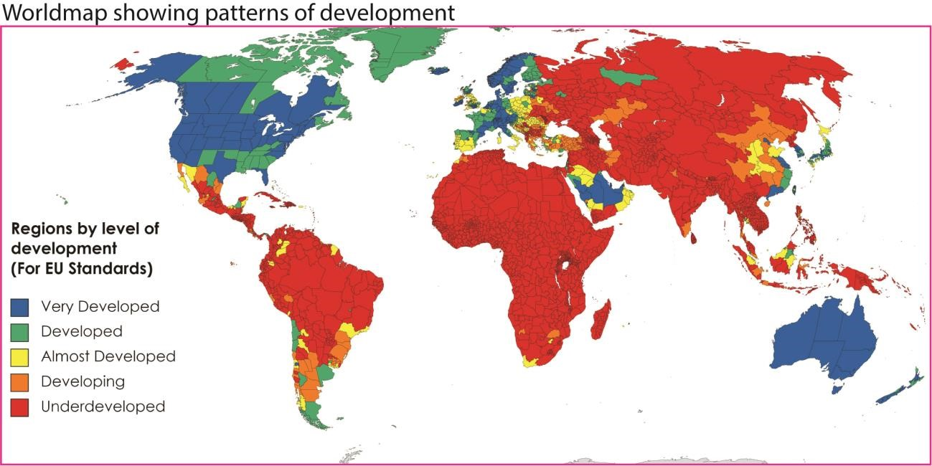

“Development" in Geography means
- Improvement in living standards: Development is about raising people's quality of life, including income, health, and education.
- Economic growth: Often measured by GDP (Gross Domestic Product) or GNI (Gross National Income), showing how much wealth a country produces.
- Social progress: Includes literacy rates, life expectancy, infant mortality, and access to healthcare.
- Infrastructure and services: Development also means better housing, transport, clean water, and electricity.
- Multidimensional process: It’s not just about money—it covers political stability, equality, and environmental sustainability.

Indicators of development

Economic Indicators
- Gross Domestic Product (GDP): Value of goods and services produced in a country.
- Gross National Income (GNI): Total income earned by a country’s population.
- Economic structure: Percentage of GDP from primary (farming), secondary (industry), and tertiary (services) sectors.

Social Indicators
- Literacy rate: Percentage of people who can read and write.
- Life expectancy: Average number of years a person is expected to live.
- Infant mortality rate: Number of babies dying before age 1 per 1,000 births.
- People per doctor: Shows access to healthcare.
- Birth rate: Number of live births per 1,000 people.

Composite Indicators
- Human Development Index (HDI): Combines income, education, and health into one score.
- Calorie intake: Average daily food consumption per person. • Doctors per person: Reflects healthcare availability.

Environmental Indicators
- Carbon emissions: Measures sustainability and environmental impact.
- Access to clean water: Shows infrastructure and public health.
- Renewable energy use: Indicates sustainable development.

Comparison Table
Category | Indicator | What it Shows
Economic | GDP | Wealth produced in a country
Economic | GNI | Income earned by citizens
Social | Literacy rate | Education levels
Social | Life expectancy | Health and longevity
Social | Infant mortality | Child health outcomes
Composite | HDI | Overall development (income, education, health)
Environmental | Carbon emissions | Sustainability and pollution
Environmental | Access to clean water | Infrastructure and public health

Why Uganda and other African countries are considered developing countries
Uganda and many African countries are considered developing countries because they face challenges such as low income levels, limited industrialization, high poverty rates, weaker healthcare and education systems, and political or economic instability compared to developed nations

(i) Economic Challenges
- Low GDP and GNI: Uganda’s economy relies heavily on agriculture, with limited industrial and technological sectors.
- High poverty rates: A significant portion of the population lives below the poverty line.
- Unstable economic management: Erratic policies and reliance on aid have slowed longterm growth
- Youth Unemployment: High rates, especially among young people, straining resources and potential.
- Dependence on Commodities: Vulnerable to global price fluctuations and climate shocks (e.g., drought affecting farming).

(ii) Social Indicators
- Healthcare struggles: High infant and maternal mortality rates, limited access to doctors, and inadequate facilities.
- Education gaps: Literacy rates are improving but still lower than global averages.
- Population growth: Rapid growth strains resources, infrastructure, and job opportunities.

(iii) Political and Historical Factors
- Colonial legacy: Many African countries inherited weak institutions and economies structured for resource extraction.
- Political instability: Conflicts, corruption, and governance challenges hinder development.
- Global inequality: Unequal trade relationships and dependency on exports of raw materials limit progress.

(iv) Environmental and Infrastructure Issues
- Climate change vulnerability: Agriculture-based economies are highly affected by droughts and floods.
- Poor infrastructure: Limited access to clean water, electricity, and transport networks. • Urban-rural divide: Development is concentrated in cities, leaving rural areas behind.
(v) Underutilization of Potential:
- Despite abundant natural resources (minerals, arable land, water), many countries struggle to translate these into broad-based economic growth and development.

Comparison Table: Developed vs. Developing Countries
Aspect | Uganda / Many African Countries | Developed Countries
Economy | Agriculture-based, low GDP per capita | Industrialized, high GDP per capita
Healthcare | High infant mortality, limited doctors | Advanced healthcare, low infant mortality
Education | Lower literacy rates, limited access | High literacy rates, universal access
Infrastructure | Poor transport and utilities | Modern infrastructure
Politics | Instability and corruption | Stable governance
Important Notes
- Uganda has shown solid economic growth in recent years, but challenges like poverty, inequality, and climate change effects keep it in the “developing” category.
- Africa’s underdevelopment is not due to a single factor—it’s a mix of historical exploitation, structural economic issues, and governance problems.
- The UN classifies countries that fall short of development goals as developing or least developed, making them eligible for assistance programs.

Suitable development strategies for Uganda and/or Africa to achieve fast, overall human development
Uganda and other African countries can accelerate human development by focusing on sustainable industrialization, investment in education and healthcare, agricultural modernization, infrastructure expansion, digital innovation, and good governance

(i) Sustainable Industrialization
- Diversify economies: Move beyond agriculture into manufacturing and services.
- Value addition: Process raw materials locally (e.g., coffee, minerals) instead of exporting them unprocessed.
- Job creation: Industrial growth provides employment opportunities for the rapidly growing youth population.
- Gender Equality: Implement policies to eliminate barriers for women, reducing genderbased violence and boosting GDP.

(ii) Agricultural Transformation
- Modern farming techniques: Mechanization, irrigation, and improved seeds to boost productivity.
- Agro-processing: Linking farmers to markets through cooperatives and food industries. • Climate resilience: Invest in drought-resistant crops and sustainable practices.

(iii) Education and Skills Development
- Universal access: Expand primary and secondary education, especially for girls.
- Technical and vocational training: Equip youth with practical skills for industry and entrepreneurship.
- Digital literacy: Prepare citizens for the global knowledge economy.

(iv) Healthcare and Social Protection
- Strengthen healthcare systems: Increase doctors per capita, improve maternal and child health.
- Universal health coverage: Affordable healthcare for all citizens.
- Social safety nets: Protect vulnerable groups from poverty shocks.

(v) Infrastructure Development
- Transport networks: Roads, railways, and ports to connect rural and urban areas.
- Energy access: Expand electricity, especially renewable sources like solar and hydro.
- Water and sanitation: Improve clean water supply and waste management.

(vi) Digital Innovation and AI
- Leverage AI: Use artificial intelligence for inclusive growth in agriculture, health, and education.
- Expand internet access: Affordable broadband to bridge the digital divide.
- Support startups: Encourage innovation hubs and entrepreneurship ecosystems.

(vii) Governance and Policy Reform
- Fight corruption: Transparent institutions and accountability.
- Inclusive policies: Ensure women, youth, and marginalized groups benefit from development.
- Regional integration: Strengthen trade within Africa through the African Continental Free Trade Area (AfCFTA).

Comparison Table: Short-Term vs. Long-Term Strategies
Focus Area | Short-Term Strategy | Long-Term Strategy
Agriculture | Improve seeds and irrigation | Agro-industrialization
Education | Expand primary schooling | Build knowledge economy
Healthcare | Increase clinics and doctors | Universal health coverage
Infrastructure | Roads and clean water | Smart cities and renewable energy
Governance | Anti-corruption measures | Strong democratic institutions

Risks and Challenges
- Rapid population growth may outpace job creation.
- Climate change threatens agriculture and food security.
- Debt dependency from foreign loans can undermine sovereignty. • Unequal development may widen rural-urban gaps.

Speculation on Uganda’s level of development in 20 years, based on current development indicators and policies
By 2045, Uganda could transition from a low-income, agriculture-based economy to a middleincome, semi-industrialized nation if it successfully implements Vision 2040, leverages oil and gas, expands infrastructure, and invests in education and healthcare. However, risks like rapid population growth, climate change, and governance challenges may slow progress.
Uganda’s Development Outlook in 20 Years

Current Development Indicators
- GDP growth: Uganda has averaged 5–6% annual growth, driven by agriculture, services, and remittances.
- Population: Over 48 million today, projected to exceed 75 million by 2045, creating pressure on jobs and services.
- Social indicators: Literacy rates improving, but healthcare access remains limited. Infant and maternal mortality are still high compared to global averages.
- Infrastructure: Expanding road networks, hydropower projects, and ICT investments, but rural areas remain underserved.

Vision 2040 Policy Goals
Uganda’s Vision 2040 aims to transform the country “from a peasant to a modern and prosperous society” by strengthening fundamentals of the economy and harnessing opportunities in:
- Oil and gas: Expected to drive industrialization and energy security.
- Tourism: Leveraging natural beauty and biodiversity.
- ICT and innovation: Building a digital economy.
- Agriculture modernization: Moving from subsistence to commercial farming. • Regional trade: Using Uganda’s central location in East Africa.

Speculative Development Trajectory (2045)
Dimension | Today (2025) | Speculated 2045
Economy | Agriculture-based, GDP per capita ~$1,000 | Diversified, GDP per capita $4,000–$6,000
Energy | Hydropower + imports | Oil, gas, renewables powering industry
Education | Literacy ~76%, uneven quality | Near-universal literacy, stronger vocational/technical training
Healthcare | High infant/maternal mortality | Improved life expectancy, wider access to healthcare
Infrastructure | Expanding but uneven | Modern transport, ICT hubs, smart cities
Global role | Aid-dependent | Regional trade hub, stronger integration in  AfCFTA

Risks and Challenges
- Population growth: Uganda’s youth bulge could be an asset if jobs are created, but a liability if unemployment rises.
- Climate change: Agriculture remains vulnerable to droughts and floods.
- Governance: Corruption and political instability could derail progress.
- Debt dependency: Heavy borrowing for infrastructure may strain finances.
Projected Trajectory (Speculative Scenarios):
- Optimistic Scenario (If Policies Succeed): Uganda becomes a diversified, industrializing economy with significantly reduced poverty, better infrastructure, and a growing middle class, leveraging oil revenue effectively for broad-based growth.
- Pessimistic Scenario (If Challenges Persist): Continued reliance on oil, weak institutions, and persistent corruption could lead to slowed diversification, increased debt, and widening inequality, despite resource wealth.

Overall Speculation
If Uganda sustains Vision 2040 reforms, invests in human capital, and manages oil revenues responsibly, it could achieve middle-income status by 2045. However, without tackling governance and climate resilience, development may remain uneven, with rural areas lagging behind urban centers.

Causes of Inequalities in World Development
Inequalities in world development are caused by a mix of economic, social, political, historical, environmental, and technological factors that create uneven opportunities and living standards across countries and regions.

Major Causes of Inequalities in World Development

1. Economic Factors
- Unequal trade relationships: Many developing countries export raw materials but import expensive manufactured goods.
- Debt burdens: Heavy borrowing limits investment in social services.
- Uneven resource distribution: Some nations have abundant oil or minerals, while others lack natural wealth.
- Globalization gaps: Wealthier nations benefit more from global markets.
- Unemployment & Low Wages: Lack of quality jobs limits income and opportunity.
•

2. Social Factors
- Education disparities: Low literacy rates and poor access to schools hinder development.
- Healthcare inequality: High infant mortality and limited medical facilities in poorer nations.
- Discrimination: Gender, race, ethnicity, disability, and other social factors create unequal access to opportunities and resources.
- Social Norms: Cultural practices can exclude groups from full participation in society.

3. Political Factors
- Governance quality: Corruption and weak institutions slow progress.
- Conflict and instability: Wars and civil unrest disrupt economies and infrastructure.
- Policy priorities: Some governments fail to invest in long-term development.

4. Historical Factors
- Colonial legacy: Many African and Asian countries inherited economies designed for resource extraction.
- Slavery and exploitation: Historical injustices created long-lasting structural disadvantages.

5. Environmental Factors
- Climate vulnerability: Droughts, floods, and desertification hit agriculture-dependent economies hardest.
- Geography: Landlocked countries face higher trade costs and slower growth.
- Natural disasters: Hurricanes, earthquakes, and disease outbreaks disproportionately affect poorer nations.

6. Technological and Industrialization Gaps
- Digital divide: Limited internet access and ICT infrastructure in developing nations.
- Slow industrialization: Reliance on agriculture keeps productivity low.
- Innovation gap: Advanced economies dominate research and development.
- Skill Premium: New technologies often favor highly skilled workers, widening the gap with those with less education.

Sustainable development
Sustainable development means meeting the needs of people today without compromising the ability of future generations to meet their own needs. It balances economic growth, social equality, and environmental protection.

Pillars of Sustainable Development
The three main pillars of sustainable development are economic sustainability, social sustainability, and environmental sustainability. Together, they ensure balanced progress that supports prosperity, fairness, and ecological health.

The Three Pillars Explained

1. Economic Sustainability
- Focus: Long-term economic growth without exhausting resources.
- Examples:
  - Investing in renewable energy industries. o Supporting small businesses and innovation.
  - Ensuring fair trade and responsible consumption.
- Impact: Creates jobs, reduces poverty, and builds resilient economies.

2. Social Sustainability
- Focus: Equity, justice, and improving quality of life for all.
- Examples:
  - Universal access to education and healthcare.
  - Gender equality and empowerment of marginalized groups.
  - Community participation in decision-making.
- Impact: Builds inclusive societies where human rights are respected.

3. Environmental Sustainability
- Focus: Protecting ecosystems and managing natural resources responsibly.
- Examples:
  - Reducing carbon emissions and pollution.
  - Conserving biodiversity and forests.
  - Promoting recycling and circular economies.
- Impact: Ensures the planet remains livable for future generations.

Summary Table
Pillar | Focus | Examples
Economic sustainability | Growth with resource efficiency | Renewable energy, fair trade
Social sustainability | Equity and justice | Education, healthcare, gender equality
Environmental sustainability | Ecosystem protection | Carbon reduction, biodiversity conservation

How sustainable development leads to improvement in people’s standard of living and quality of life for the current and future generations.
Sustainable development improves people’s standard of living and quality of life by ensuring that economic growth, social progress, and environmental protection happen together. This means people today enjoy better jobs, health, education, and cleaner environments, while future generations inherit preserved resources, stable ecosystems, and fair opportunities.
Sustainable Development Improves Living Standards and quality of life through:

1. Economic Improvements
- Job creation: Green industries (renewable energy, eco-tourism, sustainable agriculture) provide employment.
- Stable growth: Economies that use resources wisely avoid crises caused by resource depletion.
- Fair trade and innovation: Encourages inclusive markets and technological progress.

2. Social Improvements
- Better healthcare: Cleaner environments reduce disease; sustainable policies expand access to medical services.
- Education access: Investment in schools and skills training empowers communities. • Equality and inclusion: Gender equity and social justice ensure everyone benefits.

3. Environmental Improvements
- Cleaner living conditions: Reduced pollution improves health and well-being.
- Resource preservation: Forests, water, and biodiversity are protected for future use.
- Climate resilience: Communities are less vulnerable to droughts, floods, and disasters.

Impact on Current vs. Future Generations
Aspect | Impact Today | Impact in Future
Jobs & economy | Green industries create employment | Long-term prosperity with resilient economies
Health | Cleaner air and water improve well-being | Lower disease burden, longer life expectancy
Education | Access to schools builds skills | Knowledge economy for innovation
Environment | Reduced pollution and waste | Preserved ecosystems and resources
Equality | Inclusion improves social harmony | Fair opportunities across generations

Why It Matters
- For current generations: Sustainable development raises living standards by improving health, education, and income.
- For future generations: It ensures resources, ecosystems, and opportunities remain intact, preventing crises like climate collapse or resource wars.

